H.T No
Regulations:
A17

Sreenidhi Institute of Science and Technology
(An Autonomous Institution)
Code No: 6CC04 Date: 04-Sept-2024 (FN)

B.Tech II-Year I- Semester External Examination, Sept - 2024 (Supplementary)
SIGNALS AND SYSTEMS (ECE)

Time: 3 Hours Max.Marks:75

Note: a) No additional answer sheets will be provided.
b) All sub-parts of a question must be answered at one place only, otherwise it will not be valued.
c) Missing data can be assumed suitably.

Bloom's Cognitive Levels of Learning (BCLL)

Remember | L1 | Apply | L3 | Evaluate | L5
Understand | L2 | Analyze | L4 | Create | L6

Part - A Max.Marks:25
Answer all QUESTIONS

 |  | BCLL | CO(s) | Marks
1 | What is meant by orthogonal signal space? | L1 | CO1 | [2M]
2 | Write short notes on Dirichlet’s conditions for Fourier series. | L1 | CO2 | [2M]
3 | Distinguish Linear Time Invariant and Linear Time Variant Systems. | L4 | CO3 | [2M]
4 | State Parseval's theorem for Discrete Fourier Series.. | L1 | CO4 | [2M]
5 | Write the statement of Sampling Theorem. | L1 | CO5 | [2M]
6 | Define Z-transform. | L1 | CO6 | [3M]
7 | Describe Hilbert Transform. | L1 | CO2 | [3M]
8 | State the BIBO criterion for stability. | L1 | CO3 | [3M]
9 | What is meant by Aliasing Effect? | L1 | CO5 | [3M]
10 | What is the relationship between Z-transform and Fourier Transform? | L2 | CO4 | [3M]
Part – B Max.Marks:50
ANSWER ANY FIVE QUESTIONS. EACH QUESTION CARRIES 10 MARKS.

 |  |  | BCLL | CO(s) | Marks
11. | a) | Define and sketch the following elementary continuous time functions.  i) Unit impulse function ii) unit step function | L3 | CO1 | [5M]
 | b) | Prove that the complex exponential functions are orthogonal functions. | L2 | CO1 | [5M]
12. |  | Obtain the Fourier components of the periodic rectangular wave form given below.  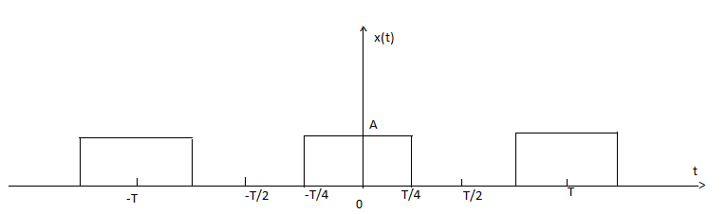 | L2 | CO2 | [10M]
13. | a) | Find which of the following systems are causal or non – causal:  - x(t) = e^{2t} u(t-1).  - x(t) = cos 2t.  - x[n] = u[-n].  - x[n] = u[n + 4] – u[n – 2]. | L3 | CO3 | [5M]
 | b) | What are the characteristics of ideal LPF and HPF? Explain. | L3 | CO3 | [5M]
14. | a) | Explain how convolution is performed using Graphical procedure. | L3 | CO4 | [5M]
 | b) | The input and the impulse response to the system are given by x(t)=u(t+2) and h(t)=u(t-3). Determine the output of the system. | L3 | CO4 | [5M]
15. | a) | State and prove sampling theorem for band limited signals. | L2 | CO5 | [5M]
 | b) | What is Aliasing? Explain in detail with spectral details of a sample data. | L3 | CO5 | [5M]
16. | a) | Derive the relation between Laplace and Z-Transform. | L4 | CO6 | [5M]
 | b) | Prove that the sequences  i)x(n)=a^{n}u(n) ii) x(n)-a^{n}u(-n-1) have the same X(z) and differ only in ROC. Also plot their ROCs. | L3 | CO6 | [5M]
17. | a) | Find the Fourier transform of the Signum function and plot its amplitude and phase spectrum. | L3 | CO1 | [4M]
 | b) | What is an LTI system? Explain its properties. | L3 | CO2 | [3M]
 | c) | Explain significance of paley-Wiener criterion for Physical Realizability. | L4 | CO3 | [3M]
18. | a) | Explain initial and final value theorems Using Laplace Transform. | L2 | CO4 | [4M]
 | b) | Explain about Flat top Sampling. | L3 | CO5 | [3M]
 | c) | Explain constraints on ROC for various classes of signals. | L2 | CO6 | [3M]

-- 00 -- 00 –

